1. **Summary of demographics**

**\* Key findings: see ‘PythonExport.xlsx’ and ‘answers.xlsx’ files for full tables.**

1/ The majority job roles of 4416 test takers are Project Management (46%). These are spread across various industries but the most popular ones are IT (17.3%), Construction/Engineering (9%), Financial services (8.4%)

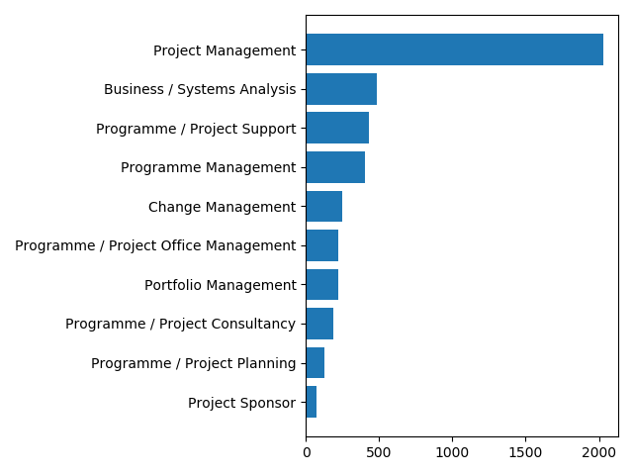

2/ By country: The most popular countries are the UK (29%) and India (27.9%)

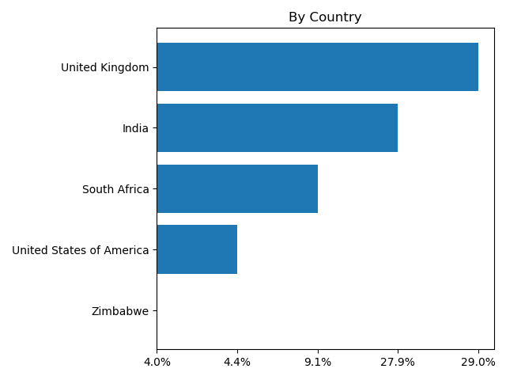

3/ By Project budgets

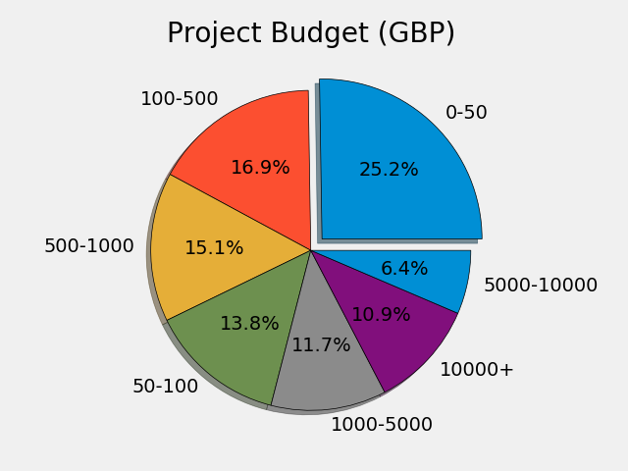

4/ By Project duration

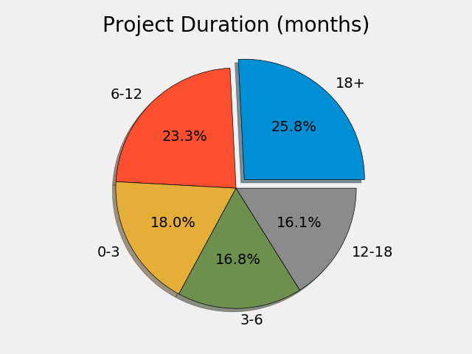

5/ By Experience

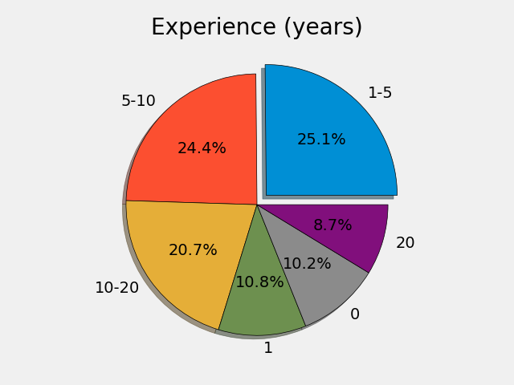

6/ Gender: almost two-third are male (65.7%)

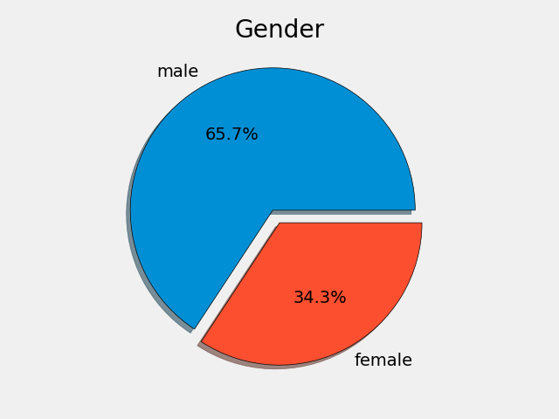

7/ Age: 95% are above 21 years old; the most popular age group is 21-34 (45.6%)

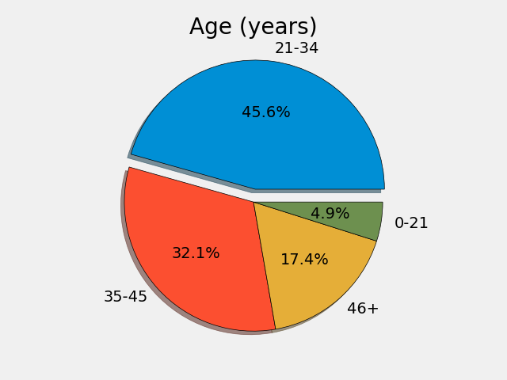

**2. Matching input questions (Q1→Q89) and output scores (R1→R7)**

* Working Python file: stats.py
* Output Excel file: Input_Output Pairs.xlsx

**\* Key findings**: Pairs of input question responses - output scores based on the statistical Pearson’s correlation coefficients. Below is a sample of the first 10 questions. The full list can be seen in **‘Input_Output Pairs.xlsx’** file.

|  |  |  |  |
| --- | --- | --- | --- |
| **Question #** | **Linked Output #** | **Question Content** | **Output** |
| Q1 | R2 | I enjoy finding new ways of resolving project issues. | creativity |
| Q2 | R1 | People think of me as a pragmatic project leader. | pragmatism |
| Q3 | R4 | I never feel anxious about anything. | stability |
| Q4 | R3 | It is better to tell team members the truth, even if it is going to demotivate them. | positive intolerance |
| Q5 | R5 | It is often difficult to make sure that the project team understands my ideas. | communication |
| Q6 | R7 | Project teams work better if they have goals in common. | group orientation |
| Q7 | R6 | I am always excited about my work projects. | motivation |
| Q8 | R2 | I try to find novel ways to solve old problems, even if old strategies worked. | creativity |
| Q9 | R1 | Thinking about ideas without considering their feasibility or practicality is a waste of time. | pragmatism |
| Q10 | R4 | Others think of me as a calm and stable individual. | stability |